Forecasting IPL Cricket Match Outcome Using Machine Learning Techniques

Ashish Garg   
Assistant Professor, Dept of Computer Science and Engineering  
Graphic Era Deemed to be UniversityDehradun, India  
ashish.garg@geu.ac.in

Kushagra Sinha  
Dept of Computer Science and Engineering  
Graphic Era Deemed to be UniversityDehradun, India  
kushagrasinha123ks@gmail.com

Shreya Agrawal   
Dept of Computer Science and Engineering  
Graphic Era Deemed to be UniversityDehradun, India  
shreyaag252004@gmail.com

*Abstract*— The Indian Premiere League (IPL) has ascended to unprecedented heights of popularity due to its fast-paced T-20 pattern and unique franchise model. Owing to its widespread appeal, IPL match prediction is a significant factor for various stakeholders. This research makes use of past match and ball data to derive several conclusions that may be applied to forecast match results. It has been emphasized how data analytics and machine learning algorithms are used. Three disparate machine learning techniques—Decision Trees, K-nearest neighbors, and random forest classifiers—are put into practice and assessed based on a list of factors, including precision, recall, accuracy, and F-measure. This study intends to provide broadcasters, teams, and cricket lovers with a tool that improves their comprehension of match dynamics and helps them make wise forecasts.

Keywords— Machine Learning, Indian Premiere League (IPL), Prediction Model, Data Visualization

# Introduction

Cricket is the most favored sport which rules the hearts of billions of people. It is a ball-and-bat sport played between two teams, each comprising 11 members, on a circular or oval-shaped field with a 22-yard horizontal pitch in the middle. The International Cricket Council (ICC) is the global organization in charge of managing cricket. It works with national cricket boards to define rules and regulations, promote the growth of cricket globally, and host international competitions. Its brand value was estimated to be around $3.67 billion for the recently concluded fourth season (Singh 2011). As of today, various formats of cricket matches are played all over the world such as One Day Internationals (ODIs), Test matches, and Twenty20 (T20) matches, which could accommodate a variety of tastes and playing techniques.

After the ICC introduced the idea of quick cricket in the form of Twenty-20 (T-20) matches, cricket's appeal grew. In 2007, ﬁrst twenty-20 world cup was held in the South Africa that was won by India which increased the popularity of this game in India (Agrawal et al. 2018). Thereafter, the BCCI (Board of Control for Cricket in India) started the revolutionary T-20 cricket league in the country called as the Indian Premier League (IPL). The IPL is an immensely populous domestic cricket competition in which players are selected from India's regional teams, national teams, and international teams. The Indian Premier League (IPL) began in 2008 with eight teams, but it currently has ten teams. To create dynamic and competitive rosters, the IPL teams, which are owned by different franchises made up of a group of persons, choose players through auctions based on their prior performances.

Cricket, often characterized as unpredictable, is undeniably influenced by past statistical data, significantly shaping match outcomes. Factors such as game regulations, team luck (toss), player skill, and performance on the day of the match all intertwine to determine the result (Singh et al. 2017), (Passi et al. 2018). Multiple other factors such as the experience of the player, the venue, and the power-play also determine the results of a cricket match. All stakeholders involved have a great deal riding on the result of the matches because money, team pride, city loyalty, and a large fan base are all involved. Therefore, an accurate prediction model (Sharma et al. 2023) is required that can forecast greater odds of one team winning over the other.

For a considerable amount of time, sports entertainment has been surrounded by data analytics and machine learning (Mukherjee 2014). The fusion of these two can help in predicting cricket match outcomes and fans can gain insightful knowledge that improves their comprehension of the intricate dynamics of the game and helps them make more accurate predictions (Bose et al. 2019), (Khanna et al. 2020). Through the use of player statistics, match history, and a multitude of other influencing factors, machine learning models are trained to identify patterns and associations that lead to accurate predictions. The data must first be scraped, organized, and pre-processed before utilizing the Machine learning algorithm. The accuracy of any prediction model is conditional on the size and kind of the dataset on which the model is trained.

In this paper, distinct machine learning techniques such as K-nearest neighbors (KNN) (Nandini et al. 2022), Decision tree (Prakash et al. 2015), and Random Forest (Patil et al. 2020) are proposed to forecast the outcomes of a cricket match. The different models are compared based on their accuracy, f1 score, and the amount of time needed to train the model. Several parameters on which the decision of the match depends such as venue, and player of the match, are visualized using the Python libraries. The contributions of the paper include:

* To implement 3 disparate machine learning techniques to predict the winner between two teams
* Comparing these algorithms based on different parameters such as Precision, accuracy, recall, and F-measure
* Visualizing some of the important conclusions from the dataset

The study is separated into 5 sections where Section I provides an introduction to this area, and Section II talks about the related works that have been done by fellow researchers. Section III covers the suggested models, visualizations, and approaches in depth. In Section IV, the overall findings are analyzed, the three proposed models are compared, and dataset insights are provided. Section V concludes this study with a discussion of potential avenues for further research in the specified field.

# Literature Review

A significant amount of research has been conducted in the field of sports such as predicting the winner of different sports, creating a team of the best players, evaluating players' performance, analyzing historical data, and visualizing it. R. Bunker et al. (2022) have focused on the fact of how specific characteristics of a sport can impact the machine learning prediction model. They have studied the aspect of how different kinds of sports (innings-dependent and time-dependent) can affect the accuracy rate of the model. Furthermore, they have discussed the elements that are crucial in predicting the winner of the sport.

In the realm of cricket, particularly Twenty20 (T20) matches, enthusiasts eagerly anticipate match predictions akin to soccer. Factors such as player rankings, performance, weather conditions, and home ground advantage significantly influence match outcomes. The study and forecasting of IPL T20 match results is covered in detail by Banasode et al. (2021). They exploit historical statistical data from IPL matches using data science, machine learning, and Python in an effort to enhance match outcome forecasts. Their study, which predicts outcomes with over 95% accuracy, helps IPL teams make well-informed decisions. A unique method for ranking batsmen in the Indian Premier League (IPL) and assessing player performance in Twenty20 (T20) cricket was presented by Manju et al. (2023). They use a three-step technique that includes setting performance parameters, assigning responsibilities to participants, and analyzing team dynamics through social network analysis. By addressing the drawbacks of conventional rankings, this approach provides insightful information that helps managers, coaches, and analysts evaluate players' strengths and weaknesses more precisely.

A comprehensive analysis of the relationship between toss-related factors and cricket player performance in the Indian Premier League (IPL) from 2008 to 2018 was conducted by Kanungo et al. (2019). The author used data visualization to highlight important player metrics including as runs, centuries, and toss results, which helped team owners and selectors make strategic decisions on team selection and performance enhancement. Tripathi et al. (2020) used historical data from 2008–2019 to anticipate the winners of IPL matches using machine learning. They preprocessed the IPL dataset using a variety of data science methods, such as feature engineering and data mining. They trained classification models, taking into account problems such as multicollinearity and model ambiguity. They discovered that tree-based classifiers, such as Random Forest, produced the most accurate predictions, attaining an accuracy of 60.043%. Talking about cricket, One-Day Internationals (ODIs) are the most entertaining matches as all the best players in the country are playing against one another. N. Pathak et al. (2016) have implemented three classification techniques – Random Forest (60.02% accuracy), SVM (61.67% accuracy), and Naïve Bayes (60.18% accuracy). They have also created a UI tool Cricket Outcome Predictor (COP) which predicts the loss and win percentage of an ODI match. This tool inputs the details for team names, toss outcome, and classifier and gives the probability outcome. The largest cricket event in India is IPL, and it has a great fan following. Ahmed et al. (2022) estimate the score of the first innings in cricket matches using machine learning and deep learning algorithms, with a specific focus on IPL matches. They use error analysis to assess their models and use Ridge Regression and Linear Regression. After cleaning the IPL dataset from Kaggle, the model is implemented in a graphical user interface created with Flask and HTML. A. Khetan et al. (2021) have also worked in the same area to foresee the champion of an IPL match. They have implemented four contrasting machine learning methods namely Logistic Regression, k-nearest Neighbor, Random Forest, and SVM - and compared them based on their accuracy. With an accuracy of 88.10%, their testing findings demonstrated that the Random Forest method works better than other algorithms.

In order to accurately assess people's opinions about the Indian Premier League 2020, Y. Kumar et al. (2021) are primarily interested in using machine learning techniques and social media data. With an emphasis on Twitter as a feedback mechanism, their study uses machine learning techniques to predict outcomes and gauge public opinion. Using comments from Twitter, this study looks at the most popular team for the 2020 IPL. Using six classification models—Random Forest, Multinomial Naïve Bayes, SGD Classifier, Ridge Classifier, Decision Tree, and Logistic Regression—the accuracy of predicting attitudes from the tweets is assessed. In order to forecast the results of IPL matches, Sudhamani et al. (2019) use machine learning to identify important variables like as team performance, venue, toss winner, and decision. Their algorithm for evaluating team points in the league is based on a multivariate regression technique. The best accuracy of 89.151% is achieved by Random Forest and Decision Tree classifiers, opening the door for the use of predictive analytics in other sports in the future. Y. Mantri et al. (2021) determines the quantitative and qualitative factors that are an important aspect to determine the winner of the IPL match. Regression analysis, the t-test, Karl Pearson's multiple correlation, chi-square test rank correlative, and other statistical methods are used in their research.

Thus, sports analytics have been approached by various researchers and different kinds of work have been done in this domain. When taken as a whole, these researches highlight the rising interest in IPL score prediction using data science and machine learning. As the field is still developing, it holds a bright future ahead and provides insightful information for sports fans, commentators, and IPL ecosystem stakeholders.

# Methodology

The four-step machine learning approach is followed in this study which includes:

* Data Gathering and Transformation
* Data Preprocessing and EDA
* Feature Engineering
* Model Training and Evaluation

The detailed model architecture is shown in Figure 1.

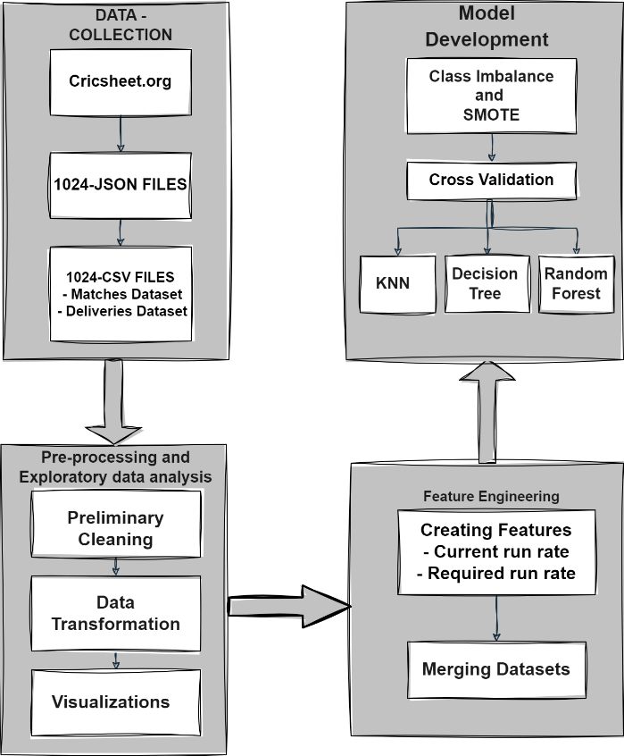

1. Detailed Model Architecture

## **Data Gathering and Transformation**

To train a machine learning model, a dataset is a first and foremost requirement. Since CricSheet is regarded as an excellent and reliable platform for collecting data related to cricket, we obtained our dataset from there which contains IPL data from 2008 to 2023 so to better analyze the matches and performances of the team. The data initially was downloaded in JSON format. It contains information about the match venue, player of the match, toss details, and winner along with details of each ball of the match. The JSON file has a nested structure which is difficult to work on so we need to convert this JSON data into a CSV file as the CSV file is structured, and simple to handle which makes it easy to analyze data. The JSON file had two kinds of attributes – info and innings. The info attribute is used to create the first dataset matches which have information like match ID, venue, the teams, winner, kind of result, win by run/wicket, etc. and the innings attribute has details for each of the balls that are played in that particular match so it is used to create deliveries dataset. The two datasets are created from the JSON file and are used to train the model. As shown in Tables I and II, the dataset matches and deliveries have 23 and 21 attributes respectively. These two datasets have a common column called match id which represents the match_id of each match played which is used to combine the two sets later in the process. The first dataset matches has 1024 records which means there are 1024 matches played from 2008-2023 and each record gives the details of each match. In the deliveries dataset, there are 243817 records which means there are this number of balls played from 2008 to 2023 and each match corresponds to a particular match ID.

1. Matches Dataset Attributes

|  |  |  |
| --- | --- | --- |
| Match ID | Season | Balls per over |
| City | dates | Referees |
| Reserve umpire | Tv umpires | Umpire1 |
| Umpire2 | winner | result |
| Player of Match | Toss decision | Toss winner |
| Dl applied | Team a | Team b |
| venue | Win by runs | Win By Wicket |
| Target overs | Target runs |  |

1. Deliveries Dataset Attributes

|  |  |  |
| --- | --- | --- |
| Match ID | Inning | Batting Team |
| Bowling Team | Over | Ball |
| Batsman | Non-striker | Bowler |
| Is super over | Wide runs | Bye runs |
| Leg bye runs | No ball runs | Penalty runs |
| Batsman runs | Extra runs | Total runs |
| Player Dismiss | Dismissal kind | Fielder |

## **Data Preprocessing and Exploratory Data Analysis**

Preprocessing of the data is required to make the dataset fit for the machine learning algorithm to work. The first step is data cleaning, which is the process of eliminating any unnecessary or undesired data that could have an impact on our model’s performance, such as redundant, NULL, or damaged data. Several teams in the IPL have changed their names, so we must update the names of those teams to reflect their new identities. Additionally, the stadium and city names need to be updated. Furthermore, as our aim is to foresee the result of only the 2024 matches, we are not interested in the matches of clubs that are no longer in existence, like the Kochi Tuskers Kerala or Pune Supergiants. So, we need to remove such match records from both the datasets along with the records where the winner of the match is unknown. We also remove records with innings more than 2 with no super over. Also, we need to merge the superovers for better data analysis.

To illustrate our findings and inferences, we analyzed the dataset and created the following visualizations. Fig 2 shows the Number count of IPL games won by each club which can be helpful to understand the past patterns and trends.

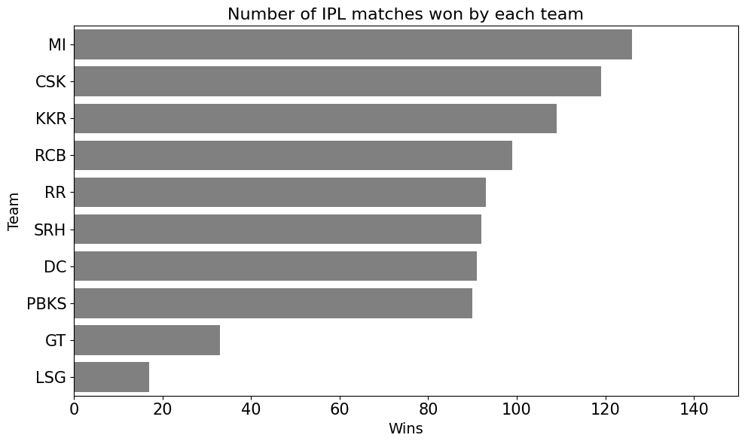

1. Number of IPL Matches won by each team

Fig 3 shows the number of matches played at different stadiums which is a crucial aspect of sports analytics, providing valuable insights into team dynamics, performance variations, and factors influencing match outcomes.

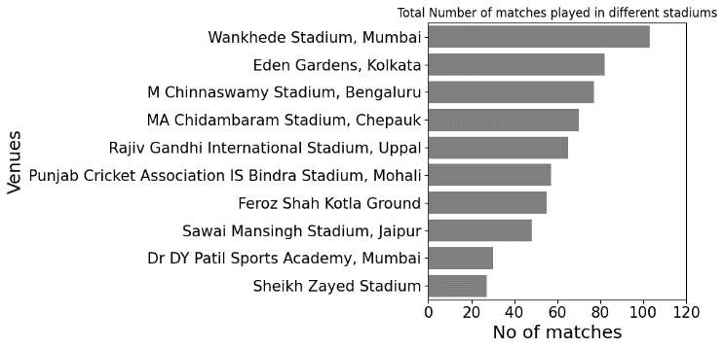

1. Total Number of games played in a varying stadiums

The amount of times a player has won Player of the Match is displayed in Fig 4. Given that the player receiving the award is a vital member of the team and helped the team win the match, this can be useful in making winning predictions.

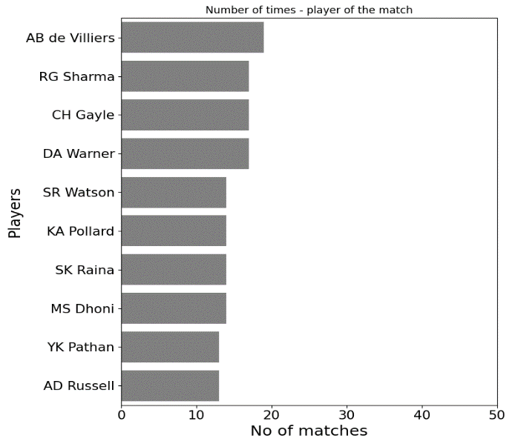

1. Number of times a player is awarded Player of the Match

Fig 5 displays the amount of times the team wins the match when winning the toss. It is insightful as the teams have particular strategies after winning the toss based on the pitch, weather conditions, and their team players.

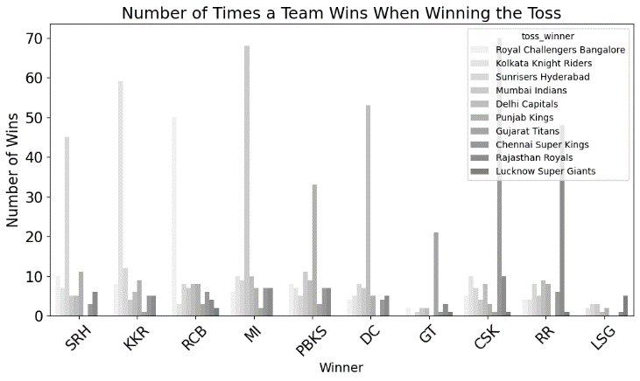

1. Number of times a Team wins when Winning the Toss

## **Feature Engineering**

For feature engineering, we’ve calculated 2 new attributes – current run rate and required run rate. These two attributes help the batting team to know how they are doing and what they need to do to win the match. Further, we need to merge the two datasets’ matches and deliveries on their common attribute match ID. The next step includes encoding the categorical variables using Label Encoder and creating the correlation matrix as shown in Figure 6 so to know which features are more related to the winning prediction column and which are more useful in training the prediction model.

## **Model Training and Evaluation**

To avoid the overfitting problem of the model, the most crucial step is to look for class imbalance, which occurs when a dataset’s class distribution is not uniform—that is, when one class has noticeably more samples than the others—and might produce a biased model. To address this, the Synthetic Minority Oversampling Technique (SMOTE), is applied, in which artificial samples specific to the minority class are created. So the issue of overfitting is resolved.

Three different Machine learning methods are proposed in this study namely- Random Forest, Decision trees, and K-nearest neighbors. All the models are trained and then cross-validation technique is applied to test the correctness of the trained model. The model's performance is assessed using this technique called cross-validation. In cross-validation, the dataset is split up into several subsets, some of which are utilised for model training and the rest for model evaluation. In this study, the dataset is splitted into 5 subsets, one is used for testing the model, while the other four are utilised for training it. The following are the machine learning algorithms on which the dataset is trained.

#### **K-Nearest Neighbors:** It is a supervised strategy for machine learning that is utilized for both regression as well as classification problems. Predicting utilising the majority class (for classification) or the average of the K nearest data points in the feature space (for regression) is the basic idea behind KNN. In the input space, it is assumed that similar instances will have similar output labels. It is a simple and easy-to-learn algorithm and works well for medium-sized datasets such as ours. Using the KneighborsClassifier class from a machine learning library, such as scikit-learn, we have initialized a KNN classifier. Since the n_neighbors parameter is set to 5, the algorithm’s prediction process will take into account the labels of the five closest neighbors.

#### **Decision Tree:** It is a technique where the algorithm learns on a set of training data and makes predictions on new, unseen data. It is a better algorithm because it handles complex, non-linear data efficiently. Represented as a tree structure, a decision tree is a hierarchical paradigm. It consists of branches that reflect the potential outcomes of a decision and nodes that each indicate a decision based on a certain attribute. Decision nodes, or internal nodes, are nodes that hold queries or conditions regarding the characteristics. The algorithm proceeds to the next set of nodes based on these requirements. Leaf nodes, also known as terminal nodes, indicate the end anticipated result or class. Every leaf node is associated with a particular categorization or judgment. A Decision Tree classifier is initialized using a

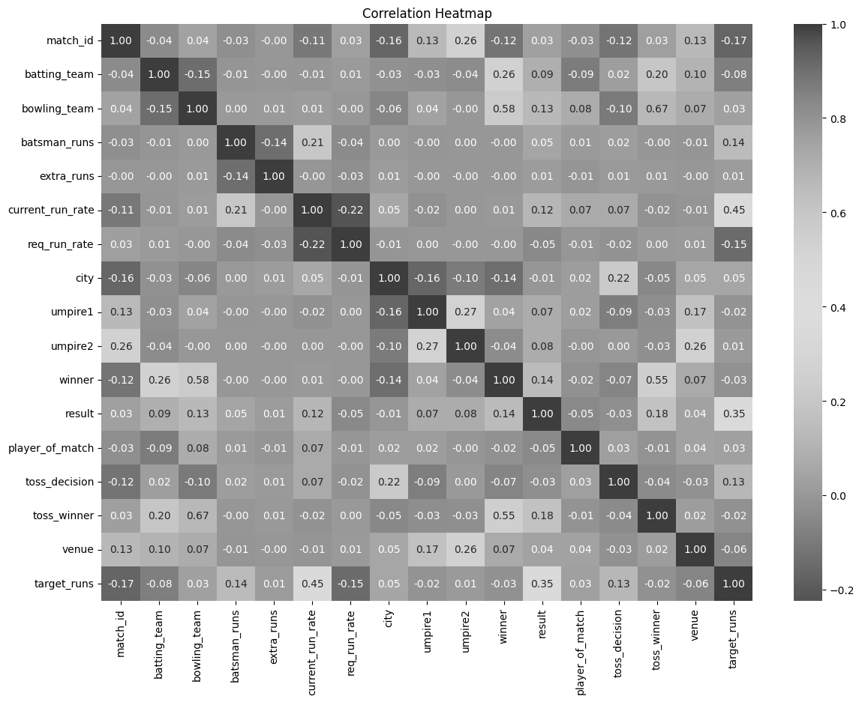

1. Visualization using Heatmap

#### random seed, a minimum number of samples required to split an internal node, a maximum tree depth and a leaf node's minimum required sample count.

#### **Random Forest:** It’s a bagging ensemble algorithm that uses many decision trees to various dataset subsets as a distinguisher. Building several decision trees and combining their predictions to get a more reliable and accurate outcome is the main principle behind Random Forest. It creates multiple bootstrap samples from the original dataset by random sampling with replacement. Even with big datasets, it provides incredibly accurate predictions with little training time. It consists of two steps: building a random forest from several decision trees in the first step, and generating predictions for each tree built in the first step. A RandomForestClassifier is initialized with 100 trees and performs 5-fold cross-validation on the resampled data.

# Result and Analysis

In the paper, three distinct machine learning models are proposed and are compared using several parameters such as accuracy, precision, F-measure, and recall, and the time taken to train and test the model, as displayed in Table III and Figure 7, 8. The study also has conducted exploratory data analysis (EDA) and derived several conclusions from it, which are essential for determining the winner.

As shown in Table III, the Random Forest outperforms the remaining algorithms with 95.02 % accuracy due to its ensemble nature and is less prone to overfitting. Random forest excels in accuracy than decision trees because it reduces variance by combining multiple trees, so it is less sensitive to training data and gives better outcomes for newer data. KNN directly depends on the closeness of data points, hence it might be susceptible to outliers and noise in the data whereas Random Forest reduces the impact of noise and outliers making itself a more robust algorithm.Random forest is the most expensive algorithm with regard to the training time, but it produces superior results. KNN, on the other hand, takes longer in terms of testing time because its training time is almost nil, making it a lazy learner. Decision trees are also superior to KNN because they require very little time for testing and training, making them quick and accurate. This entire computation is carried out on a machine configured as an Intel(R) Xeon(R) CPU running at 2.20GHz. As such, it may provide varying outcomes depending on the machine configuration.

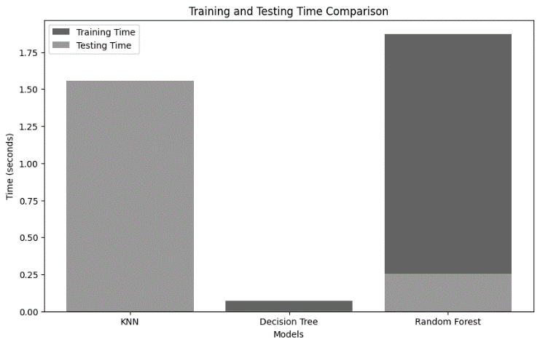

1. Comparison of different algorithms based on training and testing time

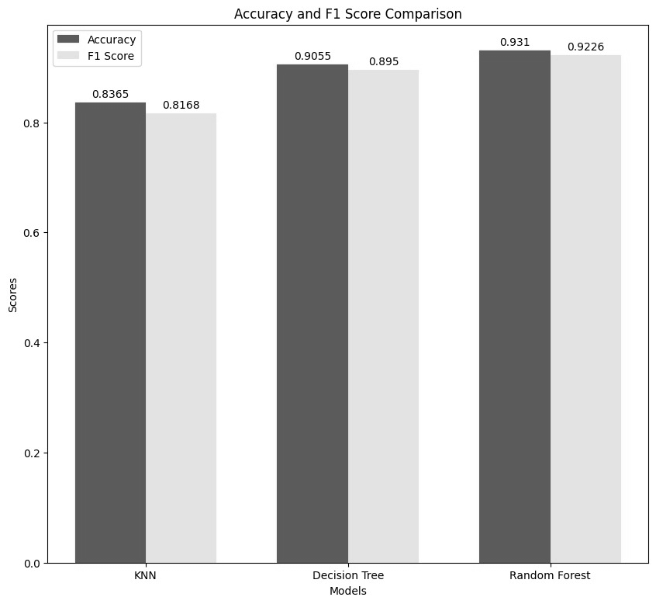Fig. 8. Comparison of different algorithms based on training and testing time

1. Comparison Of Developed Models Based On Different Parameters

|  |  |  |  |
| --- | --- | --- | --- |
| **PARAMETER/ MODELS** | **K-NEAREST NEIGHBOU-RS** | **DECISION TREE** | **RANDOM FOREST** |
| **ACCURACY** | 83.65% | 90.55% | 93.10% |
| **PRECISION** | 83.20% | 87.86% | 95.21% |
| **F1-SCORE** | 81.68% | 89.50% | 92.26% |
| **RECALL** | 83.65% | 90.55% | 93.10% |
| **TRAINING TIME (sec)** | 0.0407 | 0.0700 | 1.8727 |
| **TESTING TIME (sec)** | 1.5580 | 0.0022 | 0.2563 |

# Conclusions and Future Works

Machine learning has proved to be an effective and reliable tool in predicting the winner between the two teams in an IPL match. Through the analysis of historical match data, player statistics, and ball-by-ball details, three predictive models have been trained. Among them, Random Forest has fared better because of its ensemble nature and feature randomization, which lessens variance, prevents overfitting, and improves prediction robustness. However, it is essential to acknowledge the fact that cricket is an unpredictable sport. Due to its dynamic nature, unforeseen events, and players' form, this could challenge the predictive model. Thus, even if machine learning models offer insightful information, one should see them as instruments for well-informed decision-making rather than as infallible forecasts.

Going forward, there are several interesting avenues for more study in the area of IPL match prediction. Real-time cricket data, such as weather conditions, ball-by-ball details, and players' information, can be incorporated to build a more robust and accurate model. Further investigation into sophisticated feature engineering methods, such as sentiment analysis and detailed player dynamics, might lead to a more thorough comprehension of the affecting variables. Furthermore, exploring the suitability of deep learning models and ensemble techniques in conjunction with the incorporation of user feedback may lead to a prediction system that is more sophisticated and intuitive for users.

##### References

[1] Singh, S. (2011). Measuring the Performance of Teams in the Indian Premier League. In American Journal of Operations Research (Vol. 01, Issue 03, pp. 180–184). Scientific Research Publishing, Inc. https://doi.org/10.4236/ajor.2011.13020

[2] Agrawal, S., Singh, S. P., & Sharma, J. K. (2018). Predicting Results of Indian Premier League T-20 Matches using Machine Learning. In 2018 8th International Conference on Communication Systems and Network Technologies (CSNT). 2018 8th International Conference on Communication Systems and Network Technologies (CSNT). IEEE. https://doi.org/10.1109/csnt.2018.8820235

[3] Singh, S., & Kaur, P. (2017). IPL Visualization and Prediction Using HBase. In Procedia Computer Science (Vol. 122, pp. 910–915). Elsevier BV. https://doi.org/10.1016/j.procs.2017.11.454

[4] K. Passi and N. Pandey, “Increased Prediction Accuracy in the Game of Cricket Using Machine Learning,” Int. J. Data Min. Knowl. Manag. Process, vol. 8, no. 2, pp. 19–36, 2018, doi: https://doi.org/10.5121/ijdkp.2018.8203

[5] Sharma, N., Sharma, M., & Garg, U. (2023). Predicting Academic Performance of Students Using Machine Learning Models. In 2023 International Conference on Artificial Intelligence and Smart Communication (AISC). 2023 International Conference on Artificial Intelligence and Smart Communication (AISC). IEEE. https://doi.org/10.1109/aisc56616.2023.10085214

[6] Mukherjee, S. (2014). Quantifying individual performance in Cricket — A network analysis of batsmen and bowlers. In Physica A: Statistical Mechanics and its Applications (Vol. 393, pp. 624–637). Elsevier BV. https://doi.org/10.1016/j.physa.2013.09.027

[7] C. Bose, D. Sharma, V. Tripathi, A. Singh and P. Pandey, "A Framework for Analyzing the Exercise and Athletic Activities," 2019 6th International Conference on Computing for Sustainable Global Development (INDIACom), New Delhi, India, 2019, pp. 121-124

[8] R. Khanna, “Article ID: IJARET_11_05_102,” International Journal of Advanced Research in Engineering and Technology (IJARET), vol. 11, no. 5, pp. 954–958, 2020, doi: 10.34218/IJARET.11.5.2020.102

[9] S, S. K., HV, P., & Nandini, C. (2022). Data Science Approach to predict the winning Fantasy Cricket Team Dream 11 Fantasy Sports (Version 1). arXiv. https://doi.org/10.48550/ARXIV.2209.06999

[10] Prakash, J., Khandelwal, M., & Pradhan, T. (2015). Evaluation of IPL teams and players using association, correlation and classification rules. In 2015 International Conference on Computer, Communication and Control (IC4). 2015 International Conference on Computer, Communication and Control (IC4). IEEE. https://doi.org/10.1109/ic4.2015.7375670

[11] Patil, N., Sequeira, B. H., Gonsalves, N. N., & Singh, A. A. (2020). Cricket Team Prediction Using Machine Learning Techniques. In SSRN Electronic Journal. Elsevier BV. https://doi.org/10.2139/ssrn.3572740

[12] Bunker, R., & Susnjak, T. (2022). The Application of Machine Learning Techniques for Predicting Match Results in Team Sport: A Review. In Journal of Artificial Intelligence Research (Vol. 73, pp. 1285–1322). AI Access Foundation. https://doi.org/10.1613/jair.1.13509

[13] Banasode, P., Patil, M., & SupriyaVerma. (2021). Analysis and Predicting Results of IPL T20 Matches. In IOP Conference Series: Materials Science and Engineering (Vol. 1065, Issue 1, p. 012040). IOP Publishing. https://doi.org/10.1088/1757-899x/1065/1/012040

[14] Manju, M. K., & Philip, A. O. (2023). Novel method for ranking batsmen in Indian Premier League. In Data Science and Management (Vol. 6, Issue 3, pp. 158–173). Elsevier BV. https://doi.org/10.1016/j.dsm.2023.06.004

[15] Kanungo, V., & B, T. (2019). Data visualization and toss related analysis of IPL teams and batsmen performances. In International Journal of Electrical and Computer Engineering (IJECE) (Vol. 9, Issue 5, p. 4423). Institute of Advanced Engineering and Science. https://doi.org/10.11591/ijece.v9i5.pp4423-4432

[16] Tripathi, A. (2020). Prediction of IPL matches using Machine Learning while tackling ambiguity in results. In Indian Journal of Science and Technology (Vol. 13, Issue 38, pp. 4013–4035). Indian Society for Education and Environment. https://doi.org/10.17485/ijst/v13i38.1649

[17] Pathak, N., & Wadhwa, H. (2016). Applications of Modern Classification Techniques to Predict the Outcome of ODI Cricket. In Procedia Computer Science (Vol. 87, pp. 55–60). Elsevier BV. https://doi.org/10.1016/j.procs.2016.05.126

[18] Ahmed, R., Sareen, P., Kumar, V., Jain, R., Nagrath, P., Gupta, A., & Chawla, S. K. (2022). First inning score prediction of an IPL match using machine learning. In INNOVATIONS IN COMPUTATIONAL AND COMPUTER TECHNIQUES: ICACCT-2021. INNOVATIONS IN COMPUTATIONAL AND COMPUTER TECHNIQUES: ICACCT-2021. AIP Publishing. https://doi.org/10.1063/5.0108928

[19] Srikantaiah, K. C., Khetan, A., Kumar, B., Tolani, D., & Patel, H. (2021). Prediction of IPL Match Outcome Using Machine Learning Techniques. In Atlantis Highlights in Computer Sciences. 3rd International Conference on Integrated Intelligent Computing Communication & Security (ICIIC 2021). Atlantis Press. https://doi.org/10.2991/ahis.k.210913.049

[20] Kumar, Y., Sharma, H., & Pal, R. (2021). Popularity Measuring and Prediction Mining of IPL Team Using Machine Learning. In 2021 9th International Conference on Reliability, Infocom Technologies and Optimization (Trends and Future Directions) (ICRITO). 2021 9th International Conference on Reliability, Infocom Technologies and Optimization (Trends and Future Directions) (ICRITO). IEEE. https://doi.org/10.1109/icrito51393.2021.9596405

[21] Predictive Analysis of IPL Match Winner using Machine Learning Techniques. (2019). In International Journal of Innovative Technology and Exploring Engineering (Vol. 9, Issue 2S, pp. 430–435). Blue Eyes Intelligence Engineering and Sciences Engineering and Sciences Publication - BEIESP. https://doi.org/10.35940/ijitee.b1043.1292s19

[22] Mantri, Y. (2021). A statistical analysis of the Indian premiere league 2018-2021. In International Journal of Statistics and Applied Mathematics (Vol. 6, Issue 4, pp. 16–22). AkiNik Publications. https://doi.org/10.22271/maths.2021.v6.i4a.699